Art for All
Tutor: Tony Swann

Tuesday afternoons
14:00 – 16:00pm

This course is for all levels of ability, from complete beginners upwards – it is not formally structured and is focused on enjoyment whilst learning. Students will be shown and encouraged individually to draw and paint what they personally wish to depict.

Various techniques and media will be explored and demonstrations of usage of materials will be ongoing throughout the course. During the course exercises for the whole group will be undertaken from time to time. However, students will work mainly on their own projects.

Lead pencil, charcoal, watercolour, acrylic, pastels and coloured pencils will be the main methods of drawing and painting in this class.

Advice will be given on equipment at the start of the course. Some materials are available to borrow until students have been able to purchase their own.

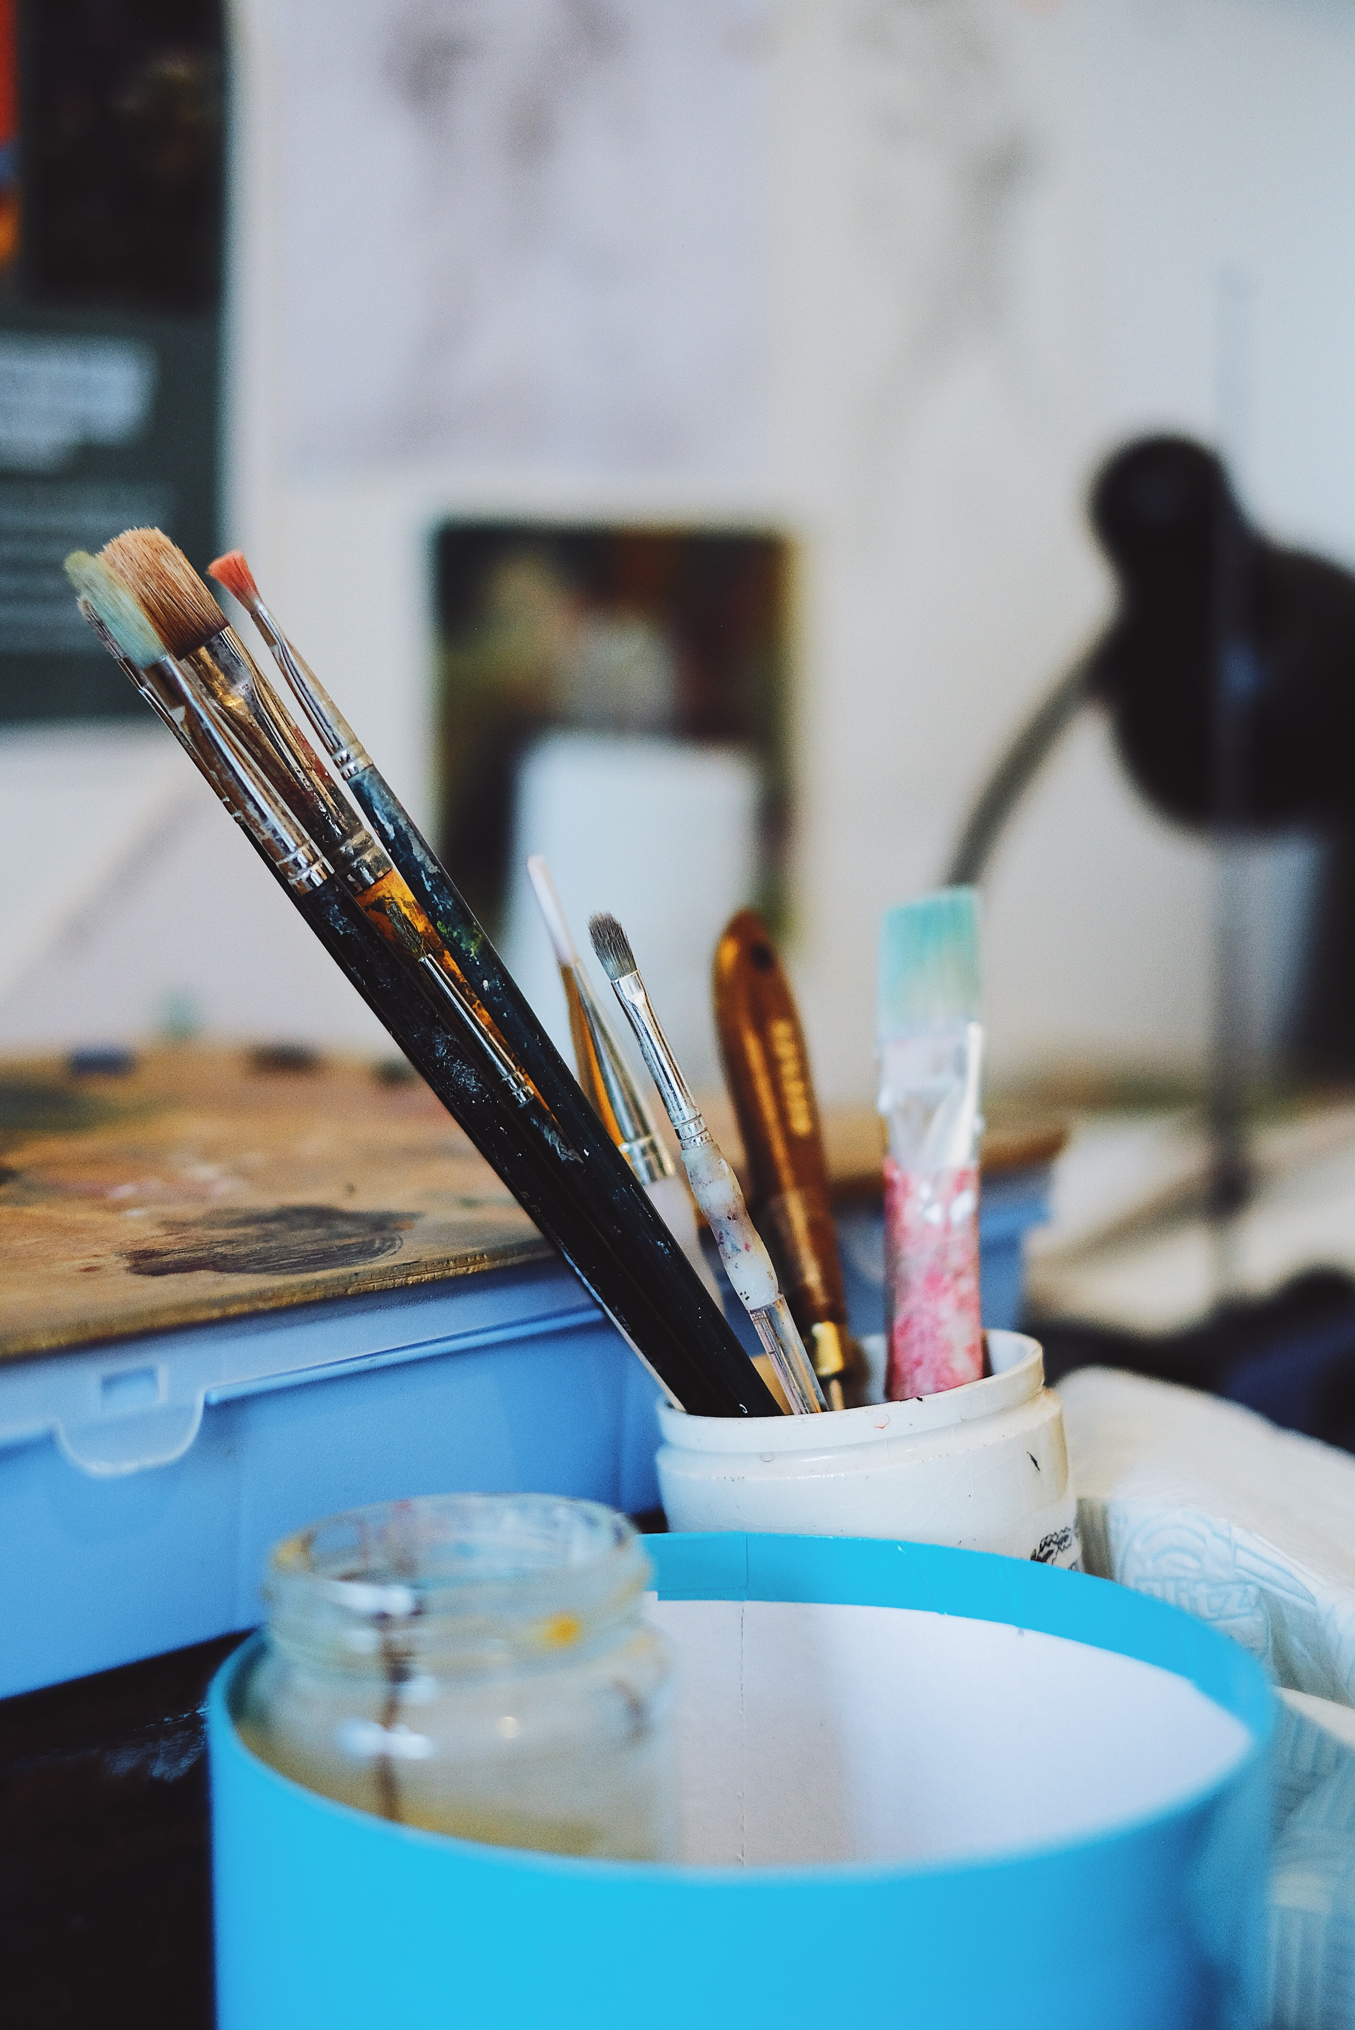
Basic start up materials are listed below, but please bring along any other materials you may have to the first class.

- 2B and 4B graphite pencils.
- Cartridge paper 90lb weight approx.
- Watercolour paper/pad 140lb./300gsm – A3 size and minimum weight.
- Watercolour and/or acrylic paints.
- Assorted brushes (as good as can be afforded).

Further equipment/ materials can be added as the course progresses (and the painting bug bites!)

Advice will be available when you need to purchase equipment.

The above equipment would be available at good art stores.

