GENTLE YOGA
Tutor: Kim Doyle
(Yoga Alliance Certified)

Thursday 10 – 11.30am

About Gentle Yoga

One of the aims of any yoga, is to harness together the ‘mind, body and spirit/soul’ through controlled breathing, meditation and specific bodily postures.

Gentle Yoga is a mindful, physical practice, it is a softer, slower style of yoga, yet still offers many of the same benefits as that of other styles. The practice ensures time is made for modifications to help people of all fitness levels and abilities. This gentler practice means less strain will be placed on muscles, joints and any injuries one may have. The mindfulness of the breath work alone will encourage the lungs to work more efficiently and help the nervous system to become more balanced, as will the combination of breath work alongside physical movements and yoga postures. Breath work and yoga poses will also encourage strength and flexibility of the body also.

Gentle Yoga Class Description

We will settle into the session with some mindful breath work, then some gentle stretches, leading into our poses mindfully with a focus on connecting our breath to our bodily movements.

The breath work and poses will encourage space, strength, releasing of tension and healing in our bodies and will end with Savasana (corpse yoga pose!) where I hope you will feel a deep sense of relaxation.

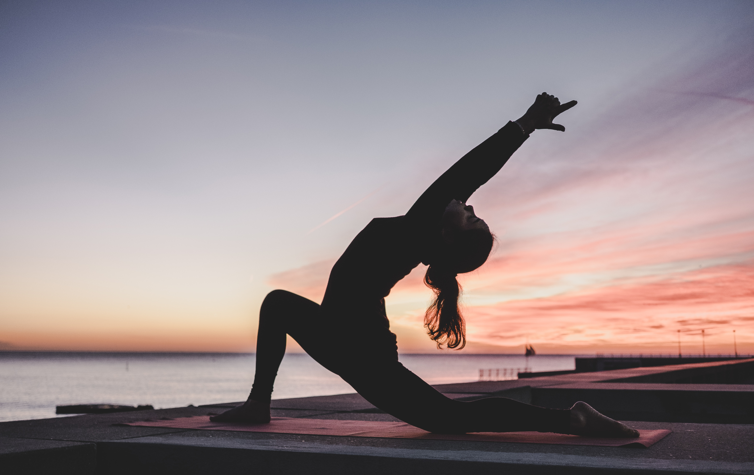What You Will Need

Comfortable clothing which allows for movement,
and a mat to lie and work on (optional: a cushion and blanket for relaxation and support. If you have yoga blocks please bring them along, if not they can be supplied. You may wish to hydrate yourself during class, if so bring a bottle of water. It is advisable to allow at least 2 hours to elapse after a meal before practising yoga.

The general requirements are loose, warm and comfortable clothing, a mat or blanket to lie and work on, and possibly a cushion or block to place under the head for relaxation and some postured. It is advisable to allow at least two hours to elapse after a meal before practising Yoga, with a light breakfast before a morning class (no full English breakfast before a class!)
I look forward to meeting you!

