BCHA

Painting in Acrylics & Watercolours 2023-24
Wednesday PM 2.00 - 4.15pm.

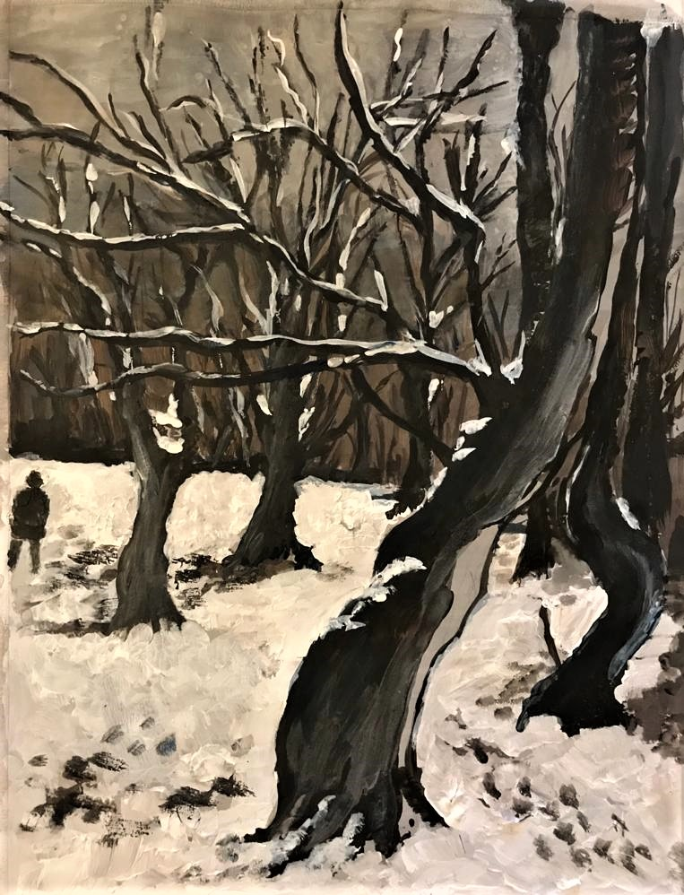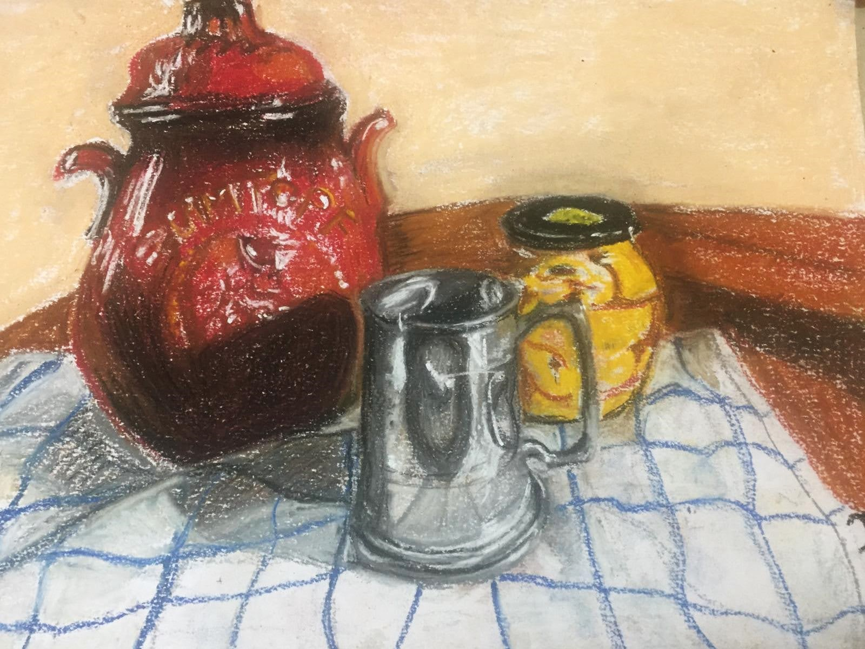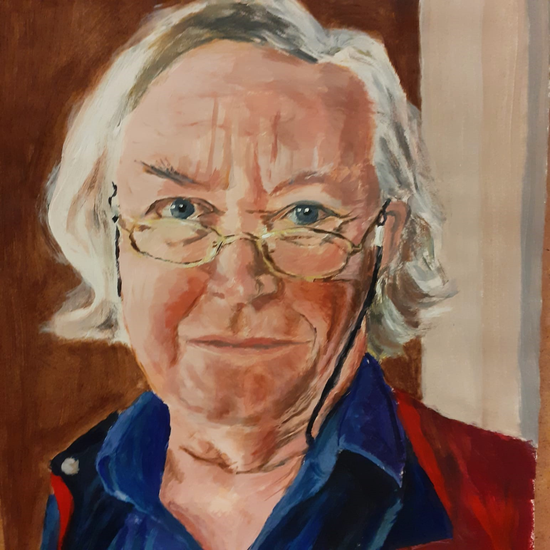

What is the course about?
This art course provides a foundation in drawing in pencil and charcoal as well as in painting in acrylics and watercolours. You will learn the basics in drawing including skills using pencil, charcoal and pastels. You will also gain skills in painting, using acrylics, oils or watercolours, tackling observation, colour-mixing and paintings techniques. This mixed-ability course helps learners to explore their own creativity and gain experience in these useful and enjoyable art skills. Later, learners can pursue their own projects guided by the tutor. The afternoon class is suitable for returning students as well as new learners who may be near beginners in art.

What will I learn?
Drawing skills such as proportion, tone and texture will be taught alongside painting techniques such as monochrome under-painting, impasto and glazing with the use of gel medium with subjects such as landscape, still life portrait and abstract art. In the summer term, watercolour techniques such as washes, glazes and “wet-in-wet” may be included. Colour-mixing is taught, as well as perspective. Pen and ink and soft pastels are sometimes used. Learners will discover more about art and artists as their awareness and practical experience of the subject increases.

How will the course be taught?

We work from life as much as possible with man-made and natural forms as well as some portrait and figure-work. With landscape and composition, we use photographs and artworks as resources.
Lots of tips and step-by-step guidance, demonstrations and individual help as well as projects and painting from still life. Learners may be asked to bring in objects for still life or reference material they have collected (photos, sketches, etc.). Occasionally slides will be shown and learners will have the chance to discuss artwork. Learners will be assessed informally on a week-to-week basis.

Will I need to buy any materials before I start?
Please bring 2B & 4B pencils, a putty rubber, a good quality A3 cartridge paper pad to the first class. Acrylics will be needed before the end of term one. Watercolours are used in the summer term. Learners are advised on the purchase of acrylics during term one.

Are there any extra costs?
As well as painting materials and equipment, you may need to bring in still life objects (e.g.flowers), or contribute a small amount to costs such as colour copies or mount-card.

Anna Bisset 2023.

